3rd Sunday after Pentecost B 3rd Sunday after Pentecost B

Lectionary 10 BLectionary 10 B

Sunday — June 9, 2024June 9, 2024 — 10:00 am
Introduction
A house divided against itself cannot stand. Jesus makes this observation in light of charges that he is possessed. He is possessed, not by a demon, but by the Holy Spirit. We who have received the Holy Spirit through baptism have been joined to Christ’s death and resurrection and knit together in the body of Christ. Those with whom we sing and pray this day are sisters and brothers of the Lord. With them we go forth in peace to do the will of God.

— Gathering —
Prelude: We Have Come Into This House CLCTeam
Prelude: We Are All One in Christ CLCTeam
Please stand as you are able in body or in spirit.
Confession and Forgiveness
All may make the sign of the cross, the sign that is marked at baptism, as the presiding minister begins.
Blessed be the holy Trinity, ☩ one God,
the God of manna,
the God of miracles,
the God of mercy.
Amen.
Drawn to Christ and seeking God’s abundance,
let us confess our sin.
Silence is kept for reflection.
God, our provider,
help us.
It is hard to believe there is enough to share.
We question your ways when they differ from the ways
of the world in which we live.
We turn to our own understanding
rather than trusting in you.
We take offense at your teachings and your ways.
Turn us again to you.
Where else can we turn?
Share with us the words of eternal life
and feed us for life in the world.
Amen.
Beloved people of God:
in Jesus, the manna from heaven, you are fed and nourished.
By Jesus, the worker of miracles, there is always more than enough.
Through Jesus, ☩ the bread of life, you are shown God’s mercy:
you are forgiven and loved into abundant life.
Amen.
Entrance Hymn: We All Are One in Christ #643
Greeting & Prayer of the Day
The grace of our Lord Jesus Christ, the love of God,
and the communion of the Holy Spirit be with you all.
And also with you.
Kyrie
words & music: Bonnie L. Drewes; © 1998

Hymn of Praise To God Be All Glory
tune: Bonnie L. Drewes; © 1998

Prayer of the Day
Let us pray. A brief silence is kept before the prayer.
All-powerful God,
in Jesus Christ you turned death into life and defeat into victory. Increase our faith and trust in him that we may triumph over all evil, in the strength of the same Jesus Christ, our Savior and Lord.
Amen.
You may be seated.

— Word —
1st Reading: The Fall Genesis 3:8-15
Immediately after Adam and Eve eat the forbidden fruit, they hide from God. Neither takes responsibility for their sin, instead blaming each other, the snake, and even God. The curse on the snake was understood as a messianic prophecy by the early church, who associated Eve’s “offspring” with Christ.
8 They heard the sound of the Lord God walking in the garden at the time of the evening breeze, and the man and his wife hid themselves from the presence of the Lord God among the trees of the garden. 9 But the Lord God called to the man and said to him, “Where are you?” 10 He said, “I heard the sound of you in the garden, and I was afraid, because I was naked, and I hid myself.” 11 He said, “Who told you that you were naked? Have you eaten from the tree of which I commanded you not to eat?” 12 The man said, “The woman whom you gave to be with me, she gave me fruit from the tree, and I ate.” 13 Then the Lord God said to the woman, “What is this that you have done?” The woman said, “The serpent tricked me, and I ate.” 14 The Lord God said to the serpent,
“Because you have done this,
cursed are you among all animals
and among all wild creatures;
upon your belly you shall go,
and dust you shall eat
all the days of your life.
15 I will put enmity between you and the woman
and between your offspring and hers;
he will strike your head,
and you will strike his heel.” [NRSVUE]
The Word of the Lord.
Thanks be to God.
Psalm of the Day Psalm 130 [R 7]
1 Out | of the depths
I cry to | you, O Lord;
2 O Lord, | hear my voice!
Let your ears be attentive to the voice of my | supplication.
3 If you were to keep watch | over sins,
O Lord, | who could stand?
4 Yet with you | is forgiveness,
in order that you | may be feared.
5 I wait for you, O Lord; | my soul waits;
in your word | is my hope.
6 My soul waits for the Lord
more than those who keep watch | for the morning,
more than those who keep watch | for the morning.
7 O Israel, wait for the Lord, for with the Lord there is | steadfast love;
with the Lord there is plen- | teous redemption.
8 For the Lord shall | redeem Israel
from | all their sins.
2nd Reading: Unseen 2 Corinthians 4:13-5:1
Life in the present is transitory and cannot compare with the eternal home god has prepared for us. So we do not despair no matter what life might bring because we know that as god raised Jesus from the dead, God promises to bring us into eternal life.
13 But just as we have the same spirit of faith that is in accordance with scripture—“I believed, and so I spoke”—we also believe, and therefore we also speak, 14 because we know that the one who raised Jesus will also raise us with Jesus and will present us with you in his presence. 15 Indeed, everything is for your sake, so that grace, when it has extended to more and more people, may increase thanksgiving, to the glory of God.
16 So we do not lose heart. Even though our outer nature is wasting away, our inner nature is being renewed day by day. 17 For our slight, momentary affliction is producing for us an eternal weight of glory beyond all measure, 18 because we look not at what can be seen but at what cannot be seen, for what can be seen is temporary, but what cannot be seen is eternal.
1 For we know that, if the earthly tent we live in is destroyed, we have a building from God, a house not made with hands, eternal in the heavens. [NRSVUE]
The Word of the Lord.
Thanks be to God.
Gospel Acclamation
tune: Bonnie L. Drewes; © 1998

Gospel: Jesus’ True Family Mark 3:20-35
In response to charges that he is possessed, Jesus wonders aloud how anyone who is demon-possessed can cast out demons. Those who do the will of God are possessed by the Holy Spirit, sisters and brothers of Christ.
The holy gospel according to Mark.
Glory to you, O Lord.
20 Then he went home, and the crowd came together again, so that they could not even eat. 21 When his family heard it, they went out to restrain him, for people were saying, “He has gone out of his mind.” 22 And the scribes who came down from Jerusalem said, “He has Beelzebul, and by the ruler of the demons he casts out demons.” 23 And he called them to him and spoke to them in parables, “How can Satan cast out Satan? 24 If a kingdom is divided against itself, that kingdom cannot stand. 25 And if a house is divided against itself, that house will not be able to stand. 26 And if Satan has risen up against himself and is divided, he cannot stand, but his end has come. 27 But no one can enter a strong man’s house and plunder his property without first tying up the strong man; then indeed the house can be plundered.
28 “Truly I tell you, people will be forgiven for their sins and whatever blasphemies they utter, 29 but whoever blasphemes against the Holy Spirit can never have forgiveness but is guilty of an eternal sin”— 30 for they had said, “He has an unclean spirit.”
31 Then his mother and his brothers came, and standing outside they sent to him and called him. 32 A crowd was sitting around him, and they said to him, “Your mother and your brothers are outside asking for you.” 33 And he replied, “Who are my mother and my brothers?” 34 And looking at those who sat around him, he said, “Here are my mother and my brothers! 35 Whoever does the will of God is my brother and sister and mother.” [NRSVUE]
The gospel of the Lord.
Praise to you, O Christ.
You may be seated.
Children’s Message: Learning from M&Ms
Sermon: Different but Not Divided Mark 3:20-35
Silence for reflection follows the sermon.
Please stand as you are able.
Hymn of the Day: We All Are One in Mission #576
Apostles’ Creed
With the whole church, let us confess our faith.
I believe in God, the Father almighty,
creator of heaven and earth.
I believe in Jesus Christ, God's only Son, our Lord.
who was conceived by the Holy Spirit,
born of the Virgin Mary,
suffered under Pontius Pilate,
was crucified, died, and was buried;
he descended to the dead.
On the third day he rose again;
he ascended into heaven,
he is seated at the right hand of the Father.
and he will come to judge the living and the dead.
I believe in the Holy Spirit,
the holy catholic Church,
the communion of saints,
the forgiveness of sins,
the resurrection of the body,
and the life everlasting. Amen.

Prayers of Intercession
We come before the triune God to pray for our communities, ourselves, and our world.
A brief silence.
You reawaken our hearts to your mercy. We give you thanks for renewers of the church in every age (especially Columba, Aiden, and Bede whom we commemorate today). Enliven the creativity and persistence of all seeking to transform the church into a closer vision of your beloved community. Merciful God,
receive our prayer.
Your presence is revealed in the shade of trees, the growth of seeds into flowers, and in the blessing of plants granting food in their right season. Heal lands scarred by deforestation, pollution, or infestation. Teach us to cultivate the earth with respect and reverence. Merciful God,
receive our prayer.
Our nations and communities are divided, O God. Teach us again to listen with curiosity and mercy, even in disagreement. Grant us the humility to acknowledge our hardness of heart and make us bold in modeling cooperation for the sake of the common good. Merciful God,
receive our prayer.
Hear the prayers of all who cry out to you from the depths of fear, despair, or hopelessness (especially). With haste, rescue victims of trafficking, exploitation, and abuse, and bless organizations and individuals who work on their behalf. Merciful God,
receive our prayer.
Grant wisdom and clarity to all who are in seasons of discernment and transition: high school graduates preparing for first jobs or new educational journeys, those who are shifting careers, and those who are navigating changes in their relationships. Accompany them with your peace. Merciful God,
receive our prayer.
Here other intercessions may be offered.
Praise to you for our ancestors in faith who believed, spoke, and lived in you (especially). Give us confidence that as Jesus was raised, so we too will be raised, with all the saints, into your everlasting presence. Merciful God,
receive our prayer.
The presider concludes the prayers.
Receive our prayers, O God, and come quickly to our aid, through the power of the Spirit and the love of Jesus Christ.
Amen.
Peace
The peace of Christ be with you always.
And also with you.
You may use these or similar words: “Peace be with you.” You may use the sign of a handshake, a hug, or a bow with palms together. Please allow those who prefer less contact to choose the level of touch.
You may be seated.

— Meal —
Gift of Music: On Eagle’s Wings Shay Andersen
Offering Is Collected
Please stand as you are able.
The Offering Is Presented and the Table Is Prepared
Offertory
words & music: Bonnie L. Drewes; © 1998

Offering Prayer
Let us pray. A brief silence is kept before the prayer.
Jesus, Bread of life,
you have set this table with your very self,
and called us to the feast of plenty.
Gather what has been sown among us,
and strengthen us in this meal.
Make us to be what we receive here,
your body for the life of the world.
Amen.

Great Thanksgiving
Sursum Corda
The Lord be with you.
And also with you.
Lift up your hearts.
We lift them to the Lord.
Let us give thanks to the Lord our God.
It is right to give our thanks and praise.
Proper Preface for Sundays
It is indeed right, our duty and our joy,
that we should at all times and in all places
give thanks and praise to you,
almighty and merciful God,
through our Savior Jesus Christ;
who on this day overcame death and the grave,
and by his glorious resurrection
opened to us the way of everlasting life.
And so, with all the choirs of angels,
with the church on earth and the hosts of heaven,
we praise your name and join their unending hymn:
Sanctus
words & music: Bonnie L. Drewes; © 1998

Table Prayer #IX
Holy God, you alone are holy, you alone are God.
The universe declares your praise:
beyond the stars;
beneath the sea;
within each cell;
with every breath.
We praise you, O God.
Generations bless your faithfulness:
through the water;
by night and day;
across the wilderness;
out of exile;
into the future.
We bless you, O God.
We give you thanks for your dear Son:
at the heart of human life;
near to those who suffer;
beside the sinner;
among the poor;
with us now.
We thank you, O God.
In the night in which he was betrayed,
our Lord Jesus took bread, and gave thanks;
broke it, and gave it to his disciples, saying:
Take and eat; this is my body, given for you.
Do this for the remembrance of me.
Again, after supper, he took the cup, gave thanks,
and gave it for all to drink, saying:
This cup is the new covenant in my blood,
shed for you and all people for the forgiveness of sin.
Do this for the remembrance of me.
Remembering his love for us on the way,
at the table,
and to the end,
we proclaim the mystery of faith:
Christ has died. Christ is risen. Christ will come again.
We pray for the gift of your Spirit:
in our gathering;
within this meal;
among your people;
throughout the world.
Come, Holy Spirit.
Blessing, praise, and thanks to you, holy God,
through Christ Jesus,
by your Spirit,
in your church,
without end.
Amen.
Lord’s Prayer
Gathered into one by the Holy Spirit, let us pray as Jesus taught us.
 | OR
1983 Version | 1892 Version
Our Father in heaven,  hallowed be your name,  your kingdom come,  your will be done,  on earth as in heaven.  Give us today our daily bread.  Forgive us our sins  as we forgive those  who sin against us.  Save us from the time of trial  and deliver us from evil.  For the kingdom, the power  and the glory are yours,  now and forever. Amen. | Our Father, who art in heaven,  hallowed be thy name,  thy kingdom come,  thy will be done,  on earth as it is in heaven.  Give us this day our daily bread;  and forgive us our trespasses,  as we forgive those  who trespass against us;  and lead us not into temptation,  but deliver us from evil.  For thine is the kingdom,  and the power, and the glory,  forever and ever. Amen.
Breaking the Bread and Invitation
Christ has set the table with more than enough for all.
Come!
You may be seated.
Communion
Communion Hymn: Lamb of God
music: Bread of Life, Jeremy Young
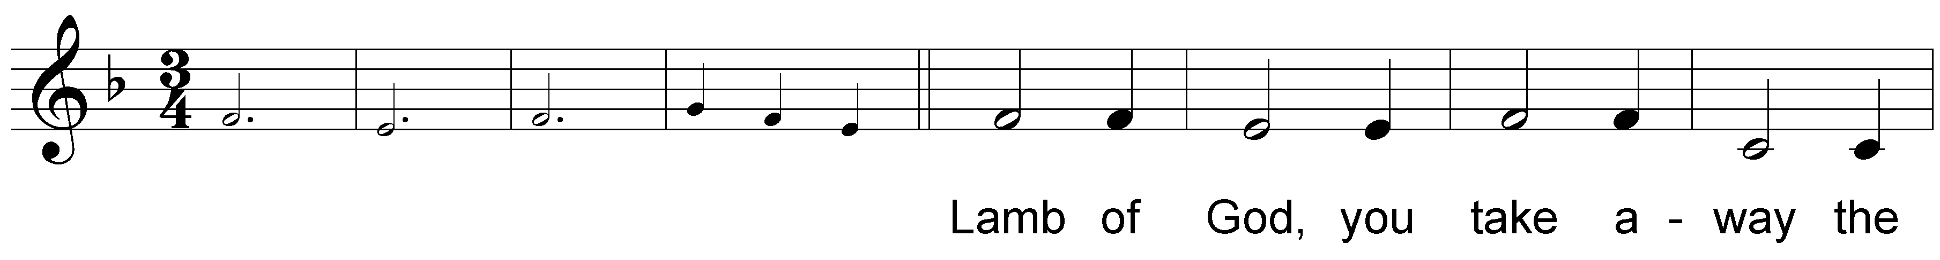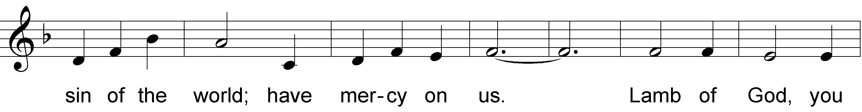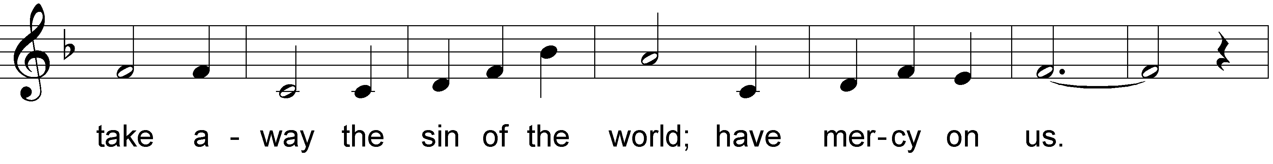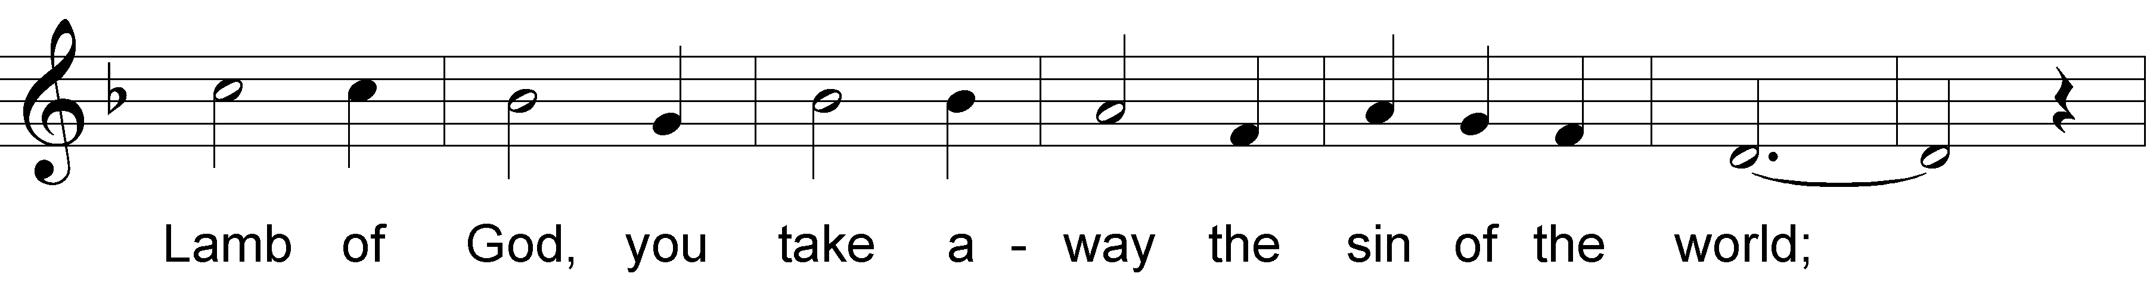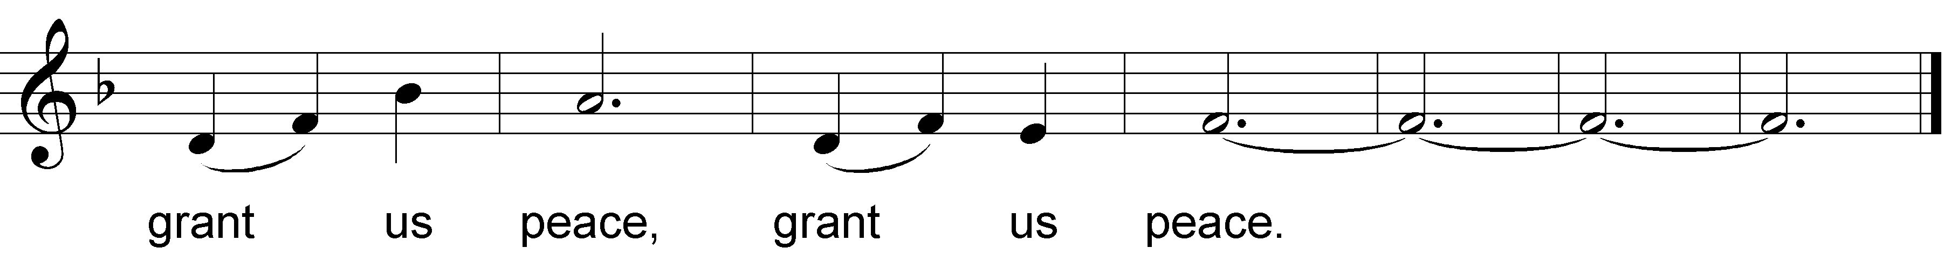
Communion Hymn: Spirit of the Living God CLCTeam
Communion Hymn: Commune with Me CLCTeam
Prayer after Communion
Let us pray. A brief silence is kept before the prayer.
Jesus, Bread of life,
we have received from your table
more than we could ever ask.
As you have nourished us in this meal,
now strengthen us to love the world with your own life.
In your name we pray.
Amen.

— Sending —
Brief Announcements, Birth/Bathdays, Anniversaries
Happy birth/bathday to you, happy anniversary to you,
may the Lord bless and keep you another year through.
Please stand as you are able.
Blessing
The blessing of God,
who provides for us, feeds us, and journeys with us,
☩ be upon you now and forever.
Amen.
Sending Hymn: Go, My Children, with My Blessing #543
Dismissal based on CLC Mission Statement
We live in Christ,
Christ lives in us.
Go in peace. Share Christ’s love with all people.
Thanks be to God.

Mark 3:32: Other ancient authorities add and sisters
The English translation of the Apostles' Creed prepared by the English Language Liturgical Consultation (ELLC), 1988
"The dead" is a more accurate translation of both the Greek word, Hades, and the Hebrew word, Sheol. Both referred to the place where all the dead go – not a place of eternal punishment. In the Creed, this line has been interpreted many different ways. Most simply it indicates that Jesus passed to Sheol – that Christ really died and was raised from death. He did not just appear dead, such as being in a coma and then waking up.
Music © 1985 Augsburg Fortress

